**WGU's Four-Step Tool** (based on "[Six Steps to Thinking Systemically](https://thesystemsthinker.com/six-steps-to-thinking-systemically/)" by Michael Goodman and Richard Karash)

**STEP 1: Complete an Iceberg Tool for this case study.**

*The Iceberg Tool is a way to see how the structure (that is, the background of the case) ties together the individual events and the patterns and trends that emerge from recurring events. Using the Iceberg Tool allows you to see the basic facts and interconnections, an important first step.*

**Iceberg Tool to Understand Patterns and Structure**

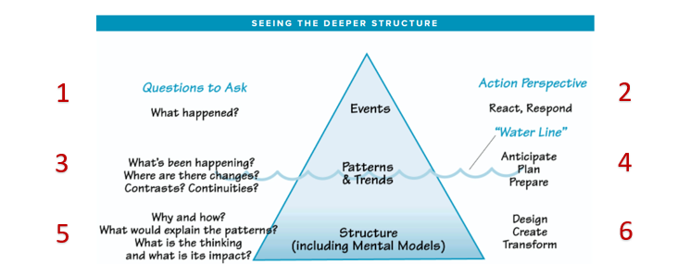

Iceberg tool shows events at the top, patterns and trends at the water line, structure near the bottom and less visible.

**Questions to Ask**

1. What are the key events in this case study?
2. The first key event mentioned in case study 2 is the increase in use of Artificial Intelligence and robots for certain tasks within the hospital. The second key event is the apparent decrease in the number of people using the hospital.
3. What patterns do you notice in the key events of this case study?  
   There are two main patterns that are identified in the case study, the first being as the number of roles being turned over to AI, the less it costs to perform those tasks. The second pattern is the apparent decrease in people using the hospital.
4. What structure(s) explain the patterns of events in this case study?
5. The decrease in patients using the hospital is probably due to how the AI usage is being perceived. AI is often portrayed as “evil” or “dangerous”. There is also a portion of the population that is against AI as it takes jobs away from humans. If the public do not know how the AI is being used within the hospital, then there may be fears of a greater risk to patient health. There is also a chance that the decrease in hospital attendance is just due to people not needing hospital attention, there is insufficient data in the case study to discount this.

**STEP 2: Draw “Behavior Over Time” Diagrams.** (Use as many blank BOT graphs as necessary, given the case study)

*The BOT diagram helps you identify how human behavior plays out over a specific time period; here, the time is the period in which the case study occurred. It is best to group similar events or patterns together in a diagram; for example, you might create one BOT diagram showing the actions of different team members (all actions) and another for the investments made in marketing campaigns and the resulting return on those investments (all money).*

Use of AI within the hospital

**Time**

**Behavior**

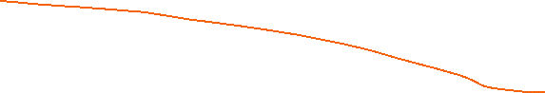

Hospital running costs.



**Time**

**Behavior**



Number of people using the hospital.

Behavior Over Time diagram; the x-axis is labeled “time”; the y-axis is labeled "behavior".

**STEP 3: Select the systems archetype that best fits the case study.** You may wish to refer to [A Pocket Guide for Using the Archetypes](https://thesystemsthinker.com/a-pocket-guide-to-using-the-archetypes/).

*The value of the eight systems archetypes is that they represent common problems within systems. If you can find an archetype that fits the system and the problem(s) you are confronting, you can use established ideas for dealing with the problem(s).*

*Examine each archetype carefully, comparing its causal loop diagram and text description with the given case study to see which one is the best fit.*

1. Which archetype did you select?

The Fixes That Fail archetype is the best fit for case study 2.

1. Why does this archetype best fit the given case study? Explain how its causal loop diagram and text description match up with the facts of the case study.

The Fixes That Fail archetype fits best as almost any decision carries long-term and short-term consequences, and the two are often diametrically opposed (Kim & Lennon, 2018). In this case, the use of AI to perform certain tasks may have helped decrease costs overall, but this action seems to have caused a decrease in the number of people using the hospital.

1. What is the main problem that needs to be addressed in this case study?

The main problem seems to be the public perception of how AI is being used in the hospital and may or may not potentially affect patient care.

**STEP 4: Generate a solution to the problem.**

*Systems thinking is a mindset and a process focused on identifying and solving problems. Without problems, there is little need to think systemically. In this step, you consider a full range of possible solutions and select the best one.*

1. What solution do you propose for the problem in this case study?  
   A solution could be to hold an open house or similar, to invite members of the public and the media into the hospital to demonstrate what tasks the AI and robots are actually performing and how they do them
2. What are the strengths of this solution?  
   The proposed solution would hopefully show which tasks the robots and AI are performing and alleviate any fears of them performing tasks that would put patient care at risk.
3. What are the challenges of this solution?

A major challenge of this solution would be the potential number of people milling around a busy hospital. This alone could put patients at risk, but as long as it was managed correctly could work out.

1. What other alternatives did you consider and why is your selected solution superior to each of them?  
   Another alternative could be to decrease the use of AI and robots within the hospital, but this would appear to go against the hospital’s target of decreasing costs.
2. What do you project the impact of your proposed solution will be on the overall system described in this case study?

The increase in AI use decreased the running costs of those tasks. This money could then be used for increased patient care focused tasks. If the public are aware of this and the fact that the AI use is not currently affecting patient care, then projections should show that hospital attendance would increase again.

# References

Kim, D., & Lannon, C. (2018). A pocket guide to using the archetypes. The Systems Thinker. https://thesystemsthinker.com/a-pocket-guide-to-using-the-archetypes/